**KH4062CEM: Skills Development 1 – Ahmed Nader**

**Command Line Cheat Code**

Ctrl + shift + T **open terminal**

Ctrl + Tab **Navigate between terminal tabs**

Ctrl + shift + W **Close terminal**

Ctrl + L / clear **Clear terminal**

Cd **Change directory**

Cd .. **Move back one directory**

Cd ~ **Move to home directory**

echo **Output a specific message**

ls / ls -l **List files in directory**

ls -la / la -a **List files in directory including the hidden ones**

ls -F **List files and their types in directory**

ls -lt **List files sorted by last modified time in directory**

ls -lh **List files in readable format in directory**

ls -lR **Shows all subdirectories**

touch **Create a file**

rm -i **Remove a file**

mkdir **Create directory/folders**

rmdir **Remove directory**

pwd **Print current directory**

cat **Print file contents**

head **Prints the first 10 lines of a file**

tail **Print the last 10 lines of a file**

diff **Checks the difference between 2 files**

cp -p **Copy a file**

mv **Move/Rename a file**

op **Open a file**

nano **Edit a file**

locate **Returns file path**

man **Help show available commands**

sudo **Change to admin to run elevated commands**

apt **Advanced Packaging Tool**

Apt-get install **Install software packages**

apt-get update **Update list of available packages**

apt-get upgrade **Install the newest version of available packages**

apt-cache pkgnames **List all available packages**

hostname **Display hostname of the system**

whoami **Display username of the users logged in at the terminal**

who **Display list of all the users currently logged in**

passwd **Change current user’s password**

uptime **Display the time for which the system has been up**

**Part 1 – Getting Started with Kali Linux:**

**

**

**4)** 

**5)** 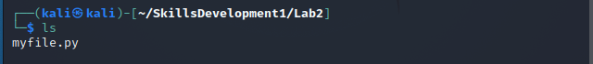

**

**

**

**Part 2 – What is the Command?:**

1. **What is the command used to copy files? cp**
2. **What is the command used to delete files and directories? rm/rmdir**
3. **What is the command used to rename files? mv**
4. **What is the command used to display the contents of a file? cat**
5. **What is the command used to clear the terminal if it gets filled up with too many commands? Clear**

**Part 3 – Generate a GIF using the command line:**

**

**Part 4 – Installing Fortune:**

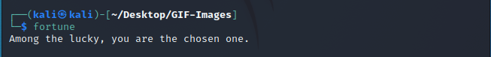

**Part 5 – Installing GIMP:**

